**INDUSTRY ANALYSIS/ INTERNAL STRATEGIC AUDIT**

**The Business Environment**

**The environment in which an organization exists could be broadly divided into two parts**; the external and the internal environment. The environment literally means the surrounding, external object, influences or circumstances under which someone exists. The environment of any organization is the aggregate of all conditions, events and influences that surround and affect it.

Throughout midst of its history, corporations have been viewed solely as economic institutions with only economic responsibilities. These responsibilities included producing goods and services to meet consumer needs, providing employment for much of the nation’s work force, paying dividends to shareholders and making provision for future growth. Where these economic responsibilities were fulfilled, the business was considered successful and to have met its obligation to the society.

**However, the last 50 years has seen a dramatic change in the environment in which the business functions. New roles have been defined for business to perform in the society. The society has devoted increasing amount of attention to issues such as pollution control, safety and health, equal opportunity and production of quality and safe products.** These concerns have resulted in the proliferation of new laws and regulations that restrict business activities that affect the society in an adverse manner. The effect of this change is dramatic change in the “rules of game” by which a business is expected to operate.

**Thus economic functions of business are no longer dominant and must be seen in relation to the social and political roles that business is being asked to assume**. The business institution is being reshaped to meet these responsibilities and must factor social and political considerations into its planning and operational process. This is the new reality businesses must learn to live.

**This changing role of business in society has, of course, made an impact on the management task within corporations. Managers have had to incorporate social and political concerns into their decision-making process.** These are becoming part of routine business operations in many corporations. Many managers have changed the way in which they view their responsibilities to society.

**Learning to understand the external environment and to consider its impact in making management decision has become the most necessary skill for every successful manager**. No business decisions today can be based solely on traditional business rationale and be successful.

The lesson that the students of strategic management need to learn is that, **in a dynamic environment, it is suicidal for organizations to remain static. They have to forego keeping an internal orientation and attempt to change dynamically as the environment changes.**

**Some of the Tools used in Industry Analysis**

**PESTEL ANALYSIS TOOL**

1. **Political:** These factors determine the extent to which a government may influence the economy or a certain industry. E.g. tax policies, Fiscal policy, trade tariffs etc. that a government may levy around the fiscal year and it may affect the business environment (economic environment) to a great extent.
2. **Economic:** These factors are determinants of an economy’s performance that directly impacts a company and have resonating long term effects. E.g. rise in the inflation rate of any economy would affect the way companies’ price their products. Economic factors include inflation rate, interest rates, foreign exchange rates, economic growth patterns etc.
3. **Social:** These factors scrutinize the social environment of the market, and gauge determinants like cultural trends, demographics, population analytics etc. An example for this can be buying trends for Western countries like the US where there is high demand during the Holiday season.
4. **Technological:** Pertain to innovations in technology that may affect the operations of the industry and the market favorably or unfavorably. E.g. automation, research and development and the amount of technological awareness that a market possesses.
5. **Environmental:** include all those that influence or are determined by the surrounding environment. This aspect of the PESTEL is crucial for certain industries particularly e.g. tourism, farming, agriculture etc. Factors of a [**business environmental analysis**](http://pestleanalysis.com/examples/pestle-analysis-business-environmental-analysis) **include but are not limited to climate, weather, geographica**l **location, global changes in climate, environmental offsets etc.**
6. **Legal:** These factors have both external and internal sides. There are certain laws that affect the business environment, and certain policies that companies maintain for themselves. Legal analysis takes into account both of these angles and then charts out the strategies in light of these legislations. E.g. consumer laws, safety standards, labor laws etc.

**2. SWOT ANALYSIS**

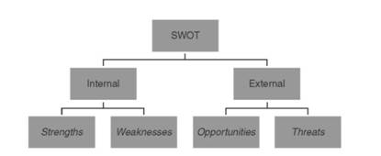

A **SWOT analysis** (alternatively **SWOT matrix**) is a structured [planning](https://en.wikipedia.org/wiki/Plan) method used to evaluate the **strengths, weaknesses, opportunities and threats** involved in a [project](https://en.wikipedia.org/wiki/Project) or in a [business](https://en.wikipedia.org/wiki/Business) venture.

A SWOT analysis can be carried out for a **product, place, industry or person**. It involves specifying the objective of the business venture or project and identifying the internal and external factors that are favorable and unfavorable to achieve that objective.

**Strength and weakness** are internal forces and factors that are to be assessed continuously since more and more competitive organizations with state of the art technology and services are entering into the market and competition is getting intensified day by day.

***Opportunities and threats*** *are the external factors and forces in the business environment which are also* changing day by day with the change of government policy, industrial policy, monetary policy, political situation at national and international levels, formation of various trade blocks and trade barriers including the changes in legal and social environment in the business world.

**Strengths***:*

Strength is the power and excellence with the resources, skills and advantages in relation to the competitors. A strength is a distinct technical superiority with best technical know-how, financial resources and skill of the people in the organization, goodwill and image in the market for the product and services, company’s access to best distribution network, the discipline, morale, attitude and mannerisms of the employees at all levels with a sense of belonging.

Management Science I Pro

**Weakness:**

Weakness is the incapability, limitation and deficiency in resources such as technical, financial, manpower, skills, brand image and distribution pattern. It refers to constraints or obstacles, which check movement in a certain direction and may also inhibit an organization in gaining a distinct competitive advantage.

**Opportunities**:

Environmental opportunity is an alternative area for company’s action in which the particular company would enjoy a competitive advantage. An opportunity is a major favorable advantage to a company. Proper analysis of the environment and identification of new market, new and improved customer group with better product substitutes or supplier’s relationship could represent opportunities for the company.

**Threats:**

Environmental threat is the challenge posed by the unavoidable trend or development that would lead, in the absence of purposeful action to the erosion of the company’s position. Slow market growth, entry of resourceful multinational companies, increase bargaining power of the buyers or sellers because of a large number of options, quick rate of obsolescence due to major technological change and adverse situation because of change of government policy rules and regulation is disadvantageous to any company and may pose a serious threat to

business operation.

Identification of SWOTs is important because they can inform later steps in planning to achieve the objective.

**3. PORTER'S FIVE FORCES ANALYSIS**

**A MODEL FOR INDUSTRY ANALYSIS**

Porter's Five Forces Analysis is an important tool for assessing the potential for profitability in an industry. Michael Porter provided a framework that models an industry as being influenced by five forces. The strategic business manager seeking to develop an edge over rival firms can use this model to better understand the industry context in which the firm operates.

**Diagram of Porter's 5 Forces**

|  |  |  |
| --- | --- | --- |
|  |  |  |
|  |  |  |
|  |  |  |

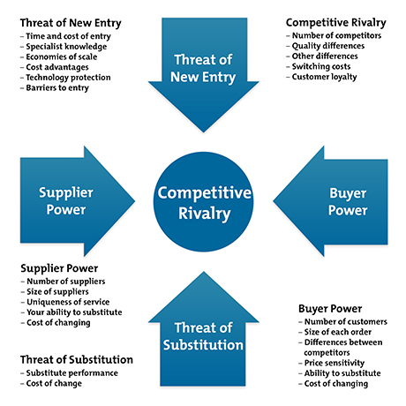

**Michael Porter’s approach to industry analysis**

Michael Porter, an authority on competitive strategy, contends that a corporation is most concerned with the intensity of competition within its industry. Basic competitive forces determine the intensity level.

The stronger each of these forces is, the more companies are limited in their ability to raise prices and earned greater profits.

1. **Threat of new entrants**

New entrants are newcomers to an existing industry. They typically bring new capacity, a desire to gain market share and substantial resources. Therefore they are threats to an established corporation. Some of the possible barriers to entry are the following.

1. Economies of scale

2. Product differentiation

3. Capital requirements

4. Switching costs

5. Access to distribution channels

6. Cost disadvantages independent of size

7. Government policy

1. **Rivalry among existing firms**

Rivalry is the strength competition in an industry. In most industries corporations are mutually dependent. A competitive move by one firm can be expected to have a noticeable effect on its competitors and thus make us revenge or counter efforts.

**According to Porter, intense rivalry is related to the presence of the following factors.**

1. number of competitors

2. rate of industry growth

3. product or service characteristics

4. amount of fixed costs

5. capacity

6. height of exit barriers

7. diversity of rivals

1. **Threat of substitute product or services**

Substitute products are those products that appear to be different but can satisfy the same need as another product. According to Porter, “Substitute limit the potential returns of an industry by placing a ceiling on the prices firms in the industry can profitably charge.” To the extent that switching costs are low, substitutes may have a strong effect on the industry.

1. **Bargaining power of buyers**

Buyers affect the industry through their ability to force down prices, bargain for higher quality or more services, and play competitors against each other.

1. **Bargaining power of supplier**

Suppliers can affect the industry through their ability to raise prices or reduce the quality of purchased goods and services.

**4. PRODUCT PORTFOLIO ANALYSIS/BCG MATRIX**

The **general purpose** of the analysis is to help understand, which brands the firm **should invest in** and which ones **should be divested**.

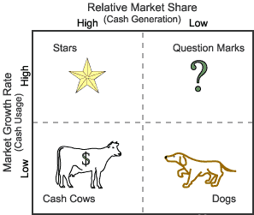

1. **Stars-** Stars represent business units having large market share in a fast growing industry. They may generate cash but because of fast growing market, stars require huge investments to maintain their lead. Net cash flow is usually modest. SBU’s located in this cell are attractive as they are located in a robust industry and these business units are highly competitive in the industry. If successful, a star will become a cash cow when the industry matures.
2. **Cash Cows-** Cash Cows represents business units having a large market share in a mature, slow growing industry. Cash cows require little investment and generate cash that can be utilized for investment in other business units. These SBU’s are the corporation’s key source of cash, and are specifically the core business. They are the base of an organization. These businesses usually follow stability strategies. When cash cows lose their appeal and move towards deterioration, then a retrenchment policy may be pursued.
3. **Question Marks-** Question marks represent business units having low relative market share and located in a high growth industry. They require huge amount of cash to maintain or gain market share. They require attention to determine if the venture can be viable. Question marks are generally new goods and services which have a good commercial prospective. There is no specific strategy which can be adopted. If the firm thinks it has dominant market share, then it can adopt expansion strategy, else retrenchment strategy can be adopted. Most businesses start as question marks as the company tries to enter a high growth market in which there is already a market-share. If ignored, then question marks may become dogs, while if huge investment is made, then they have potential of becoming stars.
4. **Dogs-** Dogs represent businesses having weak market shares in low-growth markets. They neither generate cash nor require huge amount of cash. Due to low market share, these business units face cost disadvantages. Generally retrenchment strategies are adopted because these firms can gain market share only at the expense of competitor’s/rival firms. These business firms have weak market share because of high costs, poor quality, ineffective marketing, etc. Unless a dog has some other strategic aim, it should be liquidated if there is fewer prospects for it to gain market share. Number of dogs should be avoided and minimized in an organization.

**Limitations of BCG Matrix**

The BCG Matrix produces a framework for allocating resources among different business units and makes it possible to compare many business units at a glance. But BCG Matrix is not free from limitations, such as-

1. BCG matrix classifies businesses as low and high, but generally businesses can be medium also. Thus, the true nature of business may not be reflected.
2. Market is not clearly defined in this model.
3. High market share does not always leads to high profits. There are high costs also involved with high market share.
4. Growth rate and relative market share are not the only indicators of profitability. This model ignores and overlooks other indicators of profitability.
5. At times, dogs may help other businesses in gaining competitive advantage. They can earn even more than cash cows sometimes.
6. This four-celled approach is considered as to be too simplistic.

**5. INDUSTRY VALUE CHAIN ANALYSIS**

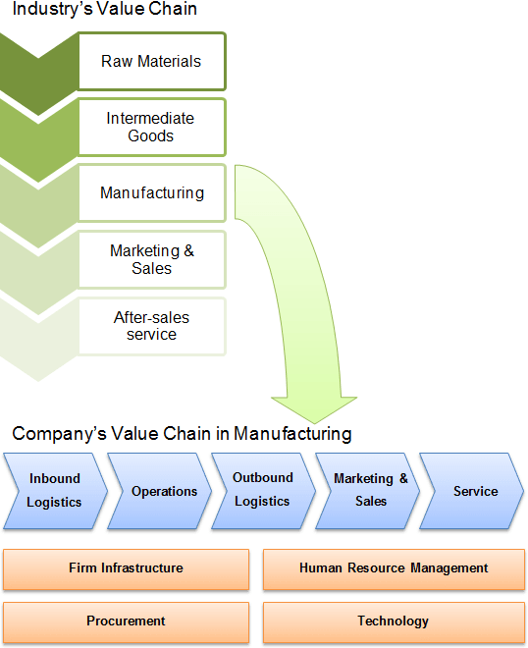

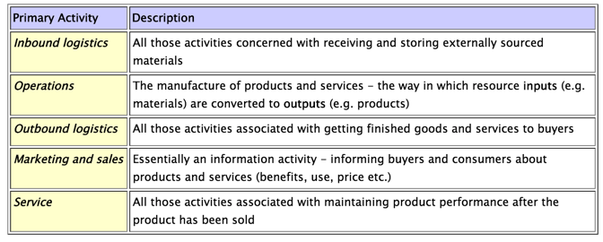

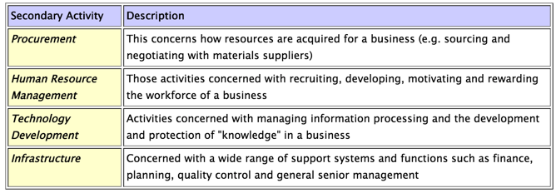

**6.MICHAEL PORTER’S GENERIC STRATEGIES MODEL**

**Competitive Advantage**

**[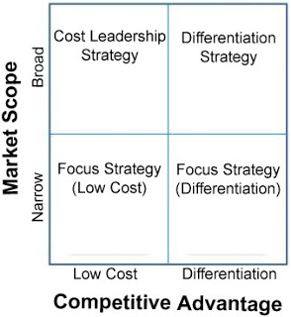](http://3.bp.blogspot.com/-o26sWqlgfcc/UYTkksHJfII/AAAAAAAAAR0/HlctSn0KxbM/s1600/Porter's+Generic+Strategies+Model.jpg)**

**Porter's Generic Strategies Model**

Michel Porter in his Porter's Generic Strategies Model, has applied firm's competitive advantages or strengths i.e. cost advantage and product differentiation in either broad or narrow market scope and identified following three generic strategies :-

1. Cost Leadership Strategy,
2. Differentiation Strategy, and
3. Focus Strategy.

These strategies are applied at business unit level. These strategies are called generic strategies because they are not dependent on specific firm or industry.

1. **Cost Leadership Strategy**

This strategy calls for being a low cost producer in an industry for a given level of quality. This strategy usually targets broad markets. The producer can charge either equal to average industry price to earn a profit higher than that of competitors, or blow average industry price to gain market share. In the situation of price war, the firm can earn some profit, but the competitors have to suffer losses. When the industry matures and prices declines, the firm that produce more cheaply will remain profitable for longer time.

The firm can reduce cost of production by improving processes efficiency, getting lower cost materials, vertical integration, optimal outsourcing, efficient distribution channels, expertise in manufacturing and engineering.

2. **Differentiation Strategy**

This strategy calls for the development of product or service that offers unique attributes and that is perceived by customers different or of greater value than the products or services of the competitors. The unique attributes makes the product different from the competitors' products and adds value to it. This added value allows the producer to charge a premium price for its product.

The unique attributes can be brought to the product through scientific research and development, creative and skilled product development team, proper communication of perceived strength of the product, innovated design and features. This strategy also targets broader market.

3. **Focus Strategy**

The focus strategy targets a narrow market or segment and within that segment attempt to achieve either cost advantage or differentiation. As the entire focus of the firm is on a group or segment, so the needs of the segment can be serviced better, and firm often gain high degree of customer loyalty.

**Conclusion**

Competitive strategy is a long term action plan that is devised by an organization to gain sustainable competitive advantage over its rivals.

1. **McKinsey’s 7S Model**

This was created by the consulting company McKinsey and company in the early 1980s. Since then it has been widely used by practitioners and academics alike in analyzing hundreds of organizations.

It explains each of the seven components of the model and the links between them.

The McKinsey 7S model was named after a consulting company, McKinsey and company, which has conducted applied research in business and industry. All of the authors worked as consultants at McKinsey and company, in the 1980s, they used the model to analyze over 70 large organizations.

The McKinsey 7S Framework was created as a recognizable and easily remembered model in business.

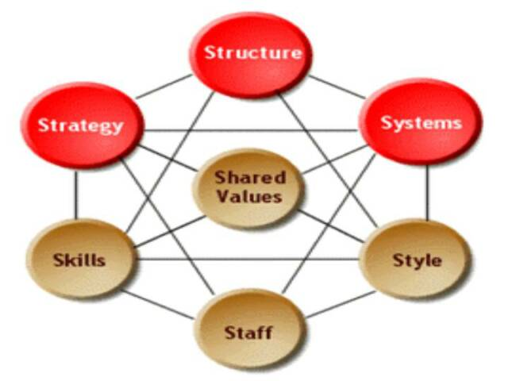

1. **Strategy:** **Strategy is the plan of action an organization prepares in response to, or anticipation of changes in its external environment**. What is your plan for the future? How do you intend to achieve the objectives? How do you deal with competitive pressure? What are the key strategic priorities such as improved customer service?
2. **Structure:** **Refers to the framework in which the activities of the organization’s members are coordinated.** i.e. focus employees’ attention on what needs to get done by defining the work they do and whom they should be working with. How is the organizational structure designed right now? How is the team divided? How do the various departments coordinate activities? How do the team members organize and align themselves?
3. **Systems:** **Refers to the day-to-day processes and procedures. Having effective systems helps reduce redundancy and streamlines process**. What are the main systems that run the organization? Where are the controls and how are they monitored and evaluated? What internal rules and processes does the team use to keep on track?
4. **Shared Values:** (also known as Super-ordinate goals): Refers to the guiding principles of the organization. These are the core values of the company and your department. What are your core and stated values? What do you measure and reward? Do they share the same company and departmental vision etc?
5. **Style:** Refers to the leadership approach and the organizations overall operating approach. How would you describe your department? How would your employees describe your department? etc
6. **Staff:**  Refers to the staff levels and how people are hired, developed, trained, socialized, integrated, and ultimately how their careers are managed. Are you staffed to serve customers adequately? Will the addition or deletion of one or two staff members change anything?
7. **Skills:** Refers to the distinctive competencies of people within the organization. What skills have you been hiring for? What skills do you need? Are there any skills gaps? How are skills monitored and assessed? etc

**Hard components are:** • Strategy, • Structure, • Systems

**Soft components are:** • Shared values, • Style, • Staff, • Skills

1. **BALANCED SCORECARD**

***What is the balanced scorecard?***

* A system of corporate appraisal which looks at financial and non-financial elements from a variety of perspectives.
* An approach to the provision of information to management to assist strategic policy formation and achievement.
* It provides the user with a set of information which addresses all relevant areas of performance in an objective and unbiased fashion.
* A set of measures that gives top managers a fast but comprehensive view of the business.

***Why the balanced scorecard…***

* Allows managers to look at the business from four important perspectives.
* Provides a balanced picture of overall performance highlighting activities that need to be improved.
* Combines both qualitative and quantitative measures.
* Relates assessment of performance to the choice of strategy.
* Includes measures of efficiency and effectiveness.
* Assists business in clarifying their vision and strategies and provides a means to translate these into action.

***In what way is the scorecard a balance?***

The scorecard produces a balance between:

* Four key business perspectives: financial, customer, internal processes and innovation.
* How the organization sees itself and how others see it.
* The short run and the long run
* The situation at a moment in time and change over time

***Main benefits of using the balanced scorecard***

* Increases the focus on the business strategy and its outcomes.
* Leads to improvised organizational performance through measurements.
* Align the workforce to meet the organization's strategy on a day-to-day basis.
* Targeting the key determinants or drivers of future performance.
* Improves the level of communication in relation to the organization's strategy and vision.
* Helps to prioritize projects according to the timeframe and other priority factors.

**The Basics of Balanced Scorecard**

Following is the simplest illustration of the concept of balanced scorecard. The four boxes represent the main areas of consideration under balanced scorecard. All four main areas of consideration are bound by the business organization's vision and strategy.

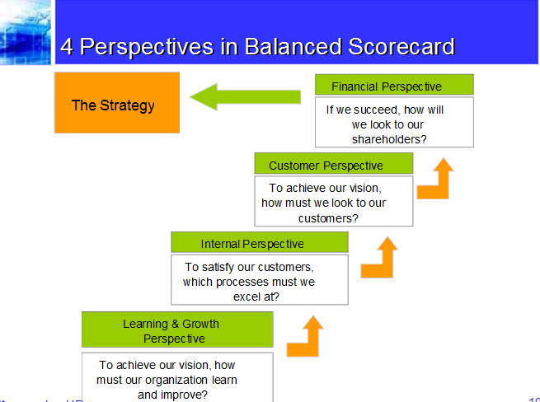

The balanced scorecard is divided into four main areas and a successful organization is one that finds the right balance between these areas.

Each area (perspective) represents a different aspect of the business organization in order to operate at optimal capacity.

* **Financial Perspective -** This consists of costs or measurement involved, in terms of rate of return on capital (ROI) employed and operating income of the organization.
* **Customer Perspective -** Measures the level of customer satisfaction, customer retention and market share held by the organization.
* **Business Process Perspective -** This consists of measures such as cost and quality related to the business processes.
* **Learning and Growth Perspective -** Consists of measures such as employee satisfaction, employee retention and knowledge management.

The four perspectives are interrelated. Therefore, they do not function independently. In real-world situations, organizations need one or more perspectives combined together to achieve its business objectives. For example, Customer Perspective is needed to determine the Financial Perspective, which in turn can be used to improve the Learning and Growth Perspective.

**Features of a Balanced Scorecard**

When it comes to defining and assessing the four perspectives, following factors are used:

* **Objectives -** This reflects the organization's objectives such as profitability or market share.
* **Measures -** Based on the objectives, measures will be put in place to gauge the progress of achieving objectives.
* **Targets -** This could be department based or overall as a company. There will be specific targets that have been set to achieve the measures.
* **Initiatives -** These could be classified as actions that are taken to meet the objectives